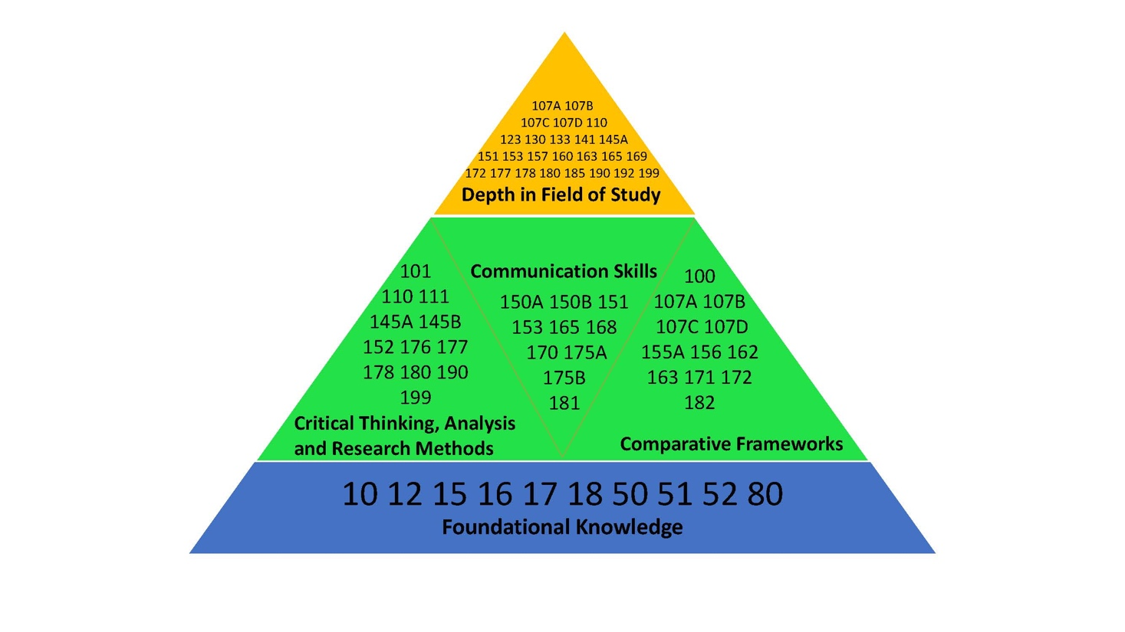AAAS Student Learning Outcomes

- Foundational Knowledge(s)
Under this learning outcome, students will gain familiarity with the material that forms the substantive foundation for subsequent study of the African American & African experience. This material includes, but is not limited to: important dates, periods, and contexts; significant figures; intellectual, artistic, political movements, etc. The courses that will support this student-learning outcome are our lower-division, introductory, survey courses.

  - Intro to African American Culture & Society (AAS 10)

  - Intro to African Studies (AAS12)

  - Intro to African American Humanities (AAS 15)

  - Verbal and Performance Arts in Africa (AAS 16)

  - Women in African Societies (AAS 17)

  - Intro to Caribbean Studies (AAS18)

  - Black Popular Culture (AAS 50)

  - History of Afro-American Dance (AAS 51)

  - African Traditional Religion (AAS 52)

  - Introduction to Black Politics (AAS 80)

- Critical Thinking, Analysis, and Research Methods
Under this learning outcome students will be exposed to more in-depth study of relevant traditions that have made up the intellectual strand of the African American & African Studies historically, politically, socially, and culturally. Moreover, Research methods in African American & African Studies will be located under this particular learning outcome. The courses that will serve this function include our upper-division courses:

  - Intro to Research in the Afro-American Community (AAS 101)

  - Cultural Politics in Contemporary Africa (AAS 111)

  - Black Social Political Thought (AAS 145A)

  - Black Intellectuals (AAS 145B)

  - Major Voices in Black Literature (AAS152)

  - West African Social Organization (AAS 110)

  - African Modernity and Globalization (AAS 178)

  - The Politics of Life in Africa (AAS 177)

  - The Politics of Resources (AAS 176)

  - Race and Ethnicity in Latin America (AAS 180)

  - Special Study for Advanced Undergraduates (AAS 199)

- Communication Skills
This learning outcome will broaden students' knowledge of the various ways peoples of African descent have historically and contemporarily expressed themselves through religion, literature, art, music, dance, film, or any other form of communication. Courses under this rubric will also be those that satisfy General Writing requirements. They will also expose students to the practical processes of creating forms of expressive culture, such as films, dance, and so on. Courses that would satisfy this learning outcome are numerous among our course offerings, including:

  - Afro-American Visual Arts Tradition... (AAS 150A, AAS 150B)

  - Afro-American Vernacular Music (AAS 151)

  - African Literature (AAS 153)

  - Afro-Christianity... (AAS 165)

  - Black Documentary: History and Practice (AAS 168)

  - African American Film and Video (AAS 170)

  - Black Documentary: History and Theory (AAS 175 A)

  - Black Documentary Practicum (AAS 175 B)

  - Hip Hop in Urban America (AAS 181)

- Comparative Frameworks
This learning outcome is based on the objective of exposing students to the study of the African Diasporic experience from within a comparative framework. This framework is designed to help students better understand the similarities as well as the differences of peoples of African descent wherever they may be found around the globe. Students will also have an opportunity to compare the experiences of African-descent peoples with those of other racial/ethnic/national backgrounds. The courses we have designated to accomplish this objective include:

  - Survey of Ethnicity in the U.S. (AAS 100)

  - African Descent Communities and Cultures in
        - Latin America and the Caribbean (AAS 107A)
        - North America (AAS 107B)
        - Asia (AAS 107C)
        - Europe (AAS 107D)

  - African-American Dance and Culture in United States, Brazil and the Caribbean (AAS 155A)

  - Language and Identity in Africa and the African Diaspora (AAS 156)

  - Islam in Africa and the Americas (AAS 162)

  - African Religions in the Americas (AAS 163)

  - Black African and Black European Film and Video (AAS 171)

  - Diaspora and New Black Identities (AAS 172)

  - Hip Hop Culture and Globalization (AAS 182)

- Depth in Field of Study

These courses build on foundational knowledge and provide an opportunity for students to acquire competency and depth in the three major areas of scholarship in the department, namely African-American Studies, African Diaspora Studies, and African Studies. The courses designated to build depth and competency include the following:

  - African Descent Communities and Cultures in
        - Latin America and the Caribbean (AAS 107A)
        - North America (AAS 107B)
        - Asia (AAS 107C)
        - Europe (AAS 107D)

  - West African Social Organization (AAS 110)

  - Black Female Experience in Contemporary Society (AAS 123)

  - Education in the African-American Community (AAS 130)

  - The Black Family in America (AAS 133)

  - Psychology of the African American Experience (AAS141)

  - Black Social and Political Thought (AAS 145A)

  - Afro-American Vernacular Music and Verbal Arts (AAS 151)

  - African Literature (AAS 153)

  - Literature and Society in South Africa (AAS 157)

  - African-American Folklore (AAS 160)

  - African Religions in the Americas (AAS 163)

  - Afro Christianity and the Black Church (AAS 165)

  - History of African American Television (AAS 169)

  - Diaspora and New Black Identities (AAS 172)

  - The Politics of Life in Africa (AAS 177)

  - African Modernity and Globalization (AAS 178)

  - Race and Ethnicity in Latin America (AAS 180)

  - Topics in African American Film (AAS 185)

  - Topics in African and African Diaspora Studies (AAS 190)

  - Internship in African American and African Studies (AAS 192)

  - Special Study for Advanced Undergraduates( AAS 199)

