How to double major in African American and African Studies?

Thanks for your interest in wanting to double major in African American and African Studies. We welcome you! If you are interested in studying the history and culture of African descent peoples, exploring both the ways in which African-descent experience is configured by social, political, and economic factors, and the aesthetic dimensions of the experience as expressed in the arts and literature, then this the major for you! We encourage all students to learn the history and culture of misrepresented groups that make up America’s nation. We are glad you are interested! Please read the steps below on double majoring in African American and African Studies.

- Contact your current major advisor to discuss double major feasibility.
- Meet with staff advisor to discuss interests.
- Take an intro class (*almost all intro classes count towards GE’s).
- Meet with peer advisor to discuss what AAS classes you might want to take.
- Meet with peer advisor or staff advisor to make an Academic Plan.
- Declare major by submitting ‘change of major’ form in OASIS (for Freshmen, declare at end of 1st quarter and for all students declare the major after 1st or 2nd quarter of taking AAS classes). All students must be in good academic standing to declare major.
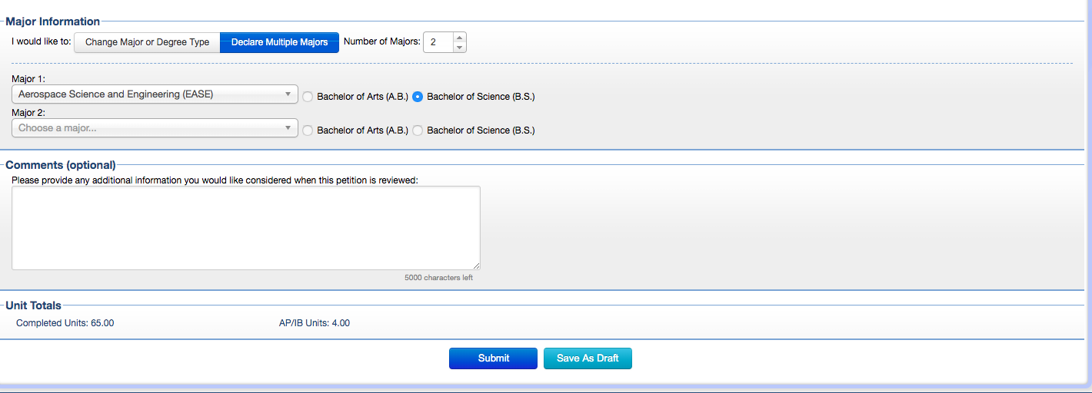
*Note: Refer to the below image for ‘change of major’ form.

